Question 1 Calc Free (5 marks)

The president of a rural shire council wants the worst of the litter removed from the verges of the roads of the shire. To prepare for the cleanup, two employees are asked to drive along each road and record, on a map, the locations that need the greatest attention.

The map of the shire roads is represented by the network below, with the road intersections shown as labelled vertices. The position of the main town is also denoted by a vertex and is marked with the letter, T.
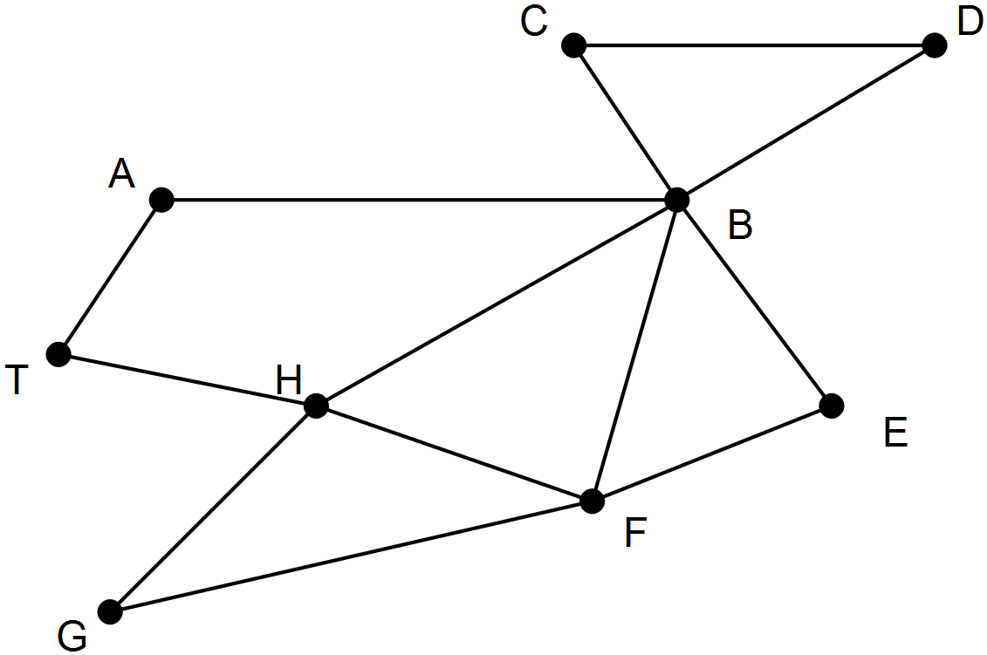

(a) The workers want to leave from and return to the main town, driving along each road in the shire only once. One of the workers can identify that such a route does exist just by looking at the map and studying the intersections.
Describe a method the worker could have used to arrive at this decision. (2 marks)

(b) Name the type of trail described in part (a) (1 mark)

(c) Identify a route that satisfies the conditions in part (a). (2 marks)

Solution Question 1 Calc Free (5 marks)

Question 1 (a)
The worker determined the degree of each vertex and concluded that the network had no odd vertices.
Marking key/mathematical behaviours | Marks
- determines degree of each vertex  - identifies there are no odd vertices | 1  1

Question 1 (b)
Eulerian.
Marking key/mathematical behaviours | Marks
- identifies type of trail | 1

Question 1 (c)
T A B E F B C D B H G F H T (or reverse order)
T A B C D B H G F B E F H T (or reverse order)
Marking key/mathematical behaviours | Marks
- lists first seven vertices in correct order  - lists remaining seven vertices in correct order | 1  1

Question 2 Calc Free (9 marks)

Over the years, a regional authority has found that the presence of a supermarket, a bank, a service station and a hotel was a good indicator of a country town’s well-being.
Below is shown a section of the table containing this information for some of the country towns. The towns are not named. They are denoted by numbers.
 |  | Service provided
 |  | Bank  (B) | Supermarket (M) | Service Station  (S) | Hotel  (H)
 | 7 | Yes | Yes | Yes | Yes
Towns | 8 | No | Yes | Yes | No
 | 9 | No | No | Yes | Yes

(a) Display the information in the table as a bipartite graph. (3 marks)
(b) Looking at this bipartite graph of the three towns, an officer at the regional authority commented that the graph was planar. (3 marks)
(i) When is a graph planar?
(ii) Draw the bipartite graph again, showing that it is planar.
(c) The officer also commented that if Town 9 had one more of the service providers, the bipartite graph would no longer be planar. (3 marks)
(i) To which of the service providers was the officer referring?
(ii) Draw the bipartite graph again showing why with this additional piece of information displayed on the graph, it is no longer a planar graph?

Solutions Question 2 Calc Free (9 marks)
Question 2 (a)
Solution
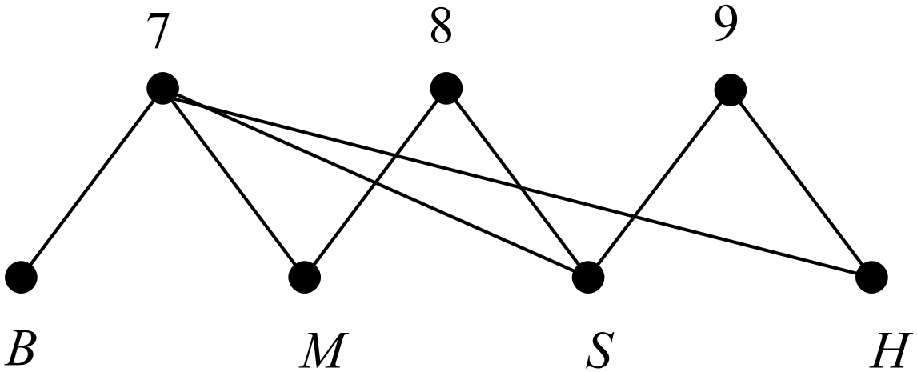
Marking key/mathematical behaviours | Marks
- identifies correct edges for Town 7  - identifies correct edges for Town 8  - identifies correct edges for Town 9 | 1  1  1
Question 2 (b)
(i) when it can be drawn on a sheet of paper without any edges crossing
(ii) 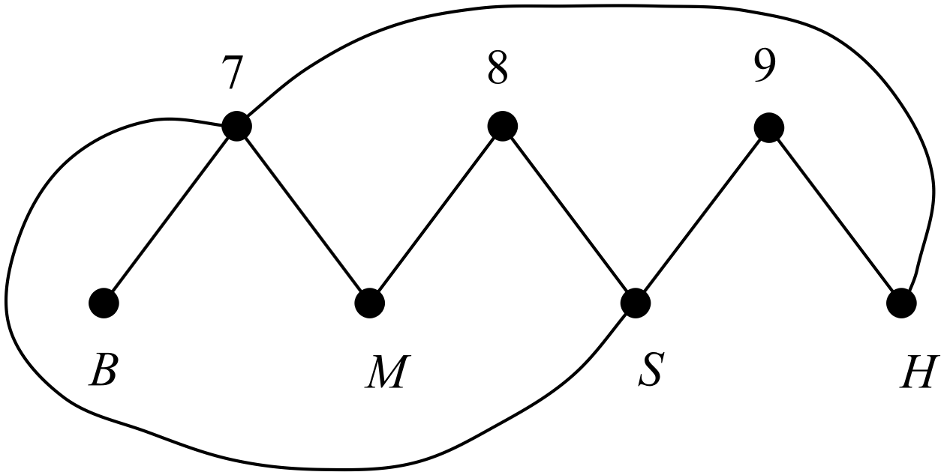
Marking key/mathematical behaviours | Marks
- describes planarity  - connects all towns with their respective services  - draws network without any edges crossing | 1  1  1

Question 2(c)
(i) Bank
(ii) Graph showing direct edge from Town 9 to the bank.
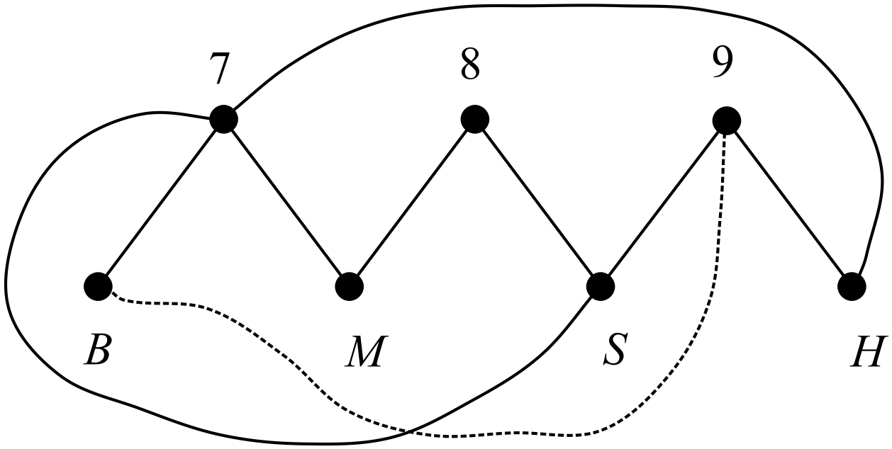
It is impossible to draw an edge from Town 9 to the bank without crossing another edge
Marking key/mathematical behaviours | Marks
- (i) designates that a bank is the additional service  - (ii) draws a graph showing edge from Town 9 to bank  - draws with correct edges crossing | 1  1  1

Question 3 Calc Free (11 marks)
Consider the following graph

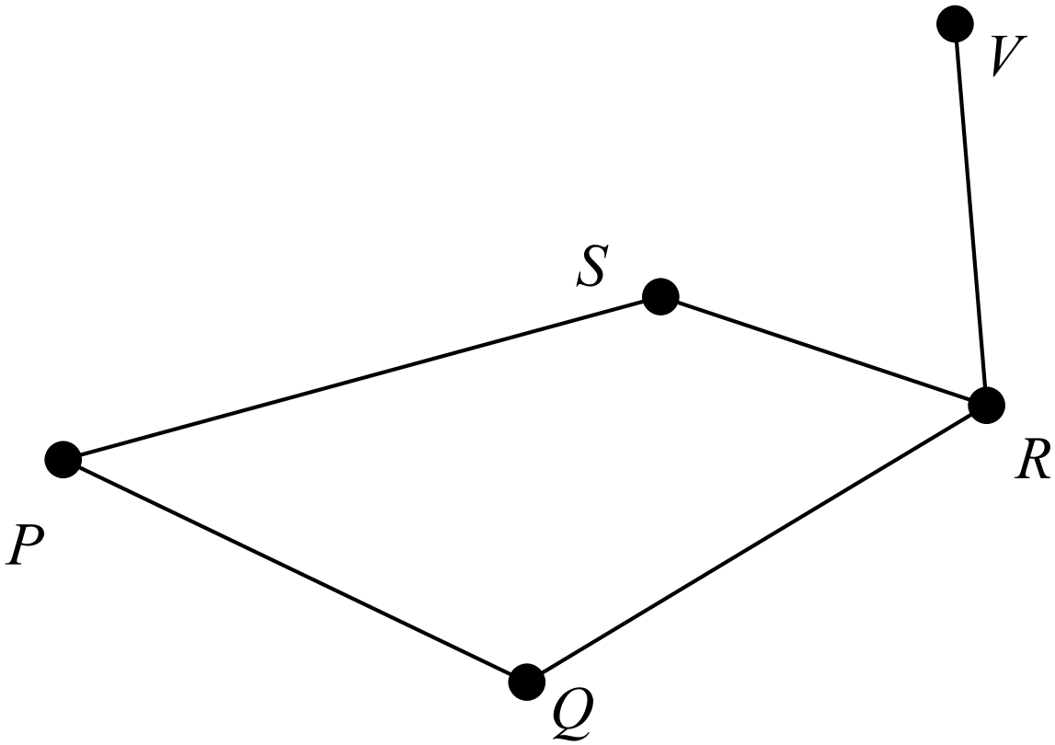
(a) Which of the types of graphs listed below describe the graph above?
Circle the letter(s) next to the type(s) that you select.
(A) a simple graph (B) a digraph (C) a planar graph

(D) a connected graph (E) a complete graph (F) a weighted graph
(3 marks)
(b) Explain why the graph above is NOT an Eulerian graph. (2 marks)
(c) Show, however, that Euler’s Rule is true for the graph. (2 marks)
(d) Explain why edge PQ is not a bridge. (2 marks)
(e) Complete the following sentence to make it a true statement.

The degree of vertex R is ........... because .................................................................
......................................................................................................................................
(2 marks)

Solutions Question 3 Calc Free (11 marks)
Question 3 (a)
Letters A, C and D should be circled
Marking key/mathematical behaviours | Marks
- selects one correct feature  - selects second correct feature  - selects third correct feature (only selecting 3) | 1  1  1
Question 3 (b)
Cannot travel every edge only once AND start and finish at same vertex
Marking key/mathematical behaviours | Marks
- describes first condition  - describes second condition | 1  1
Question 3 (c)
Euler’s Rule : n(vertices) + n(faces) – n(edges) = 2
5 + 3 – 6 = 2
Marking key/mathematical behaviours | Marks
- states Euler’s Rule  - substitutes correct number of vertices, faces and edges | 1  1
Question 3 (d)
Graph is still connected when edge PQ is removed
Marking key/mathematical behaviours | Marks
- explains graph remains connected  - when edge PQ removed | 1  1
Question 3 (e)
The degree of vertex R is 3 because exactly 3 edges meet at R .
Marking key/mathematical behaviours | Marks
- identifies degree of node  - justifies choice of value | 1  1

Question 4 Calc Free (8 marks)

A Year 12 student was trying to locate the shortest Hamiltonian circuit for a postal van to visit four connected villages, W, X, Y and Z and drew a type of “tree diagram” as shown below. The circuit had to start at village W. Use the student’s diagram, where the distances between villages are given in kilometres, to answer the questions below.

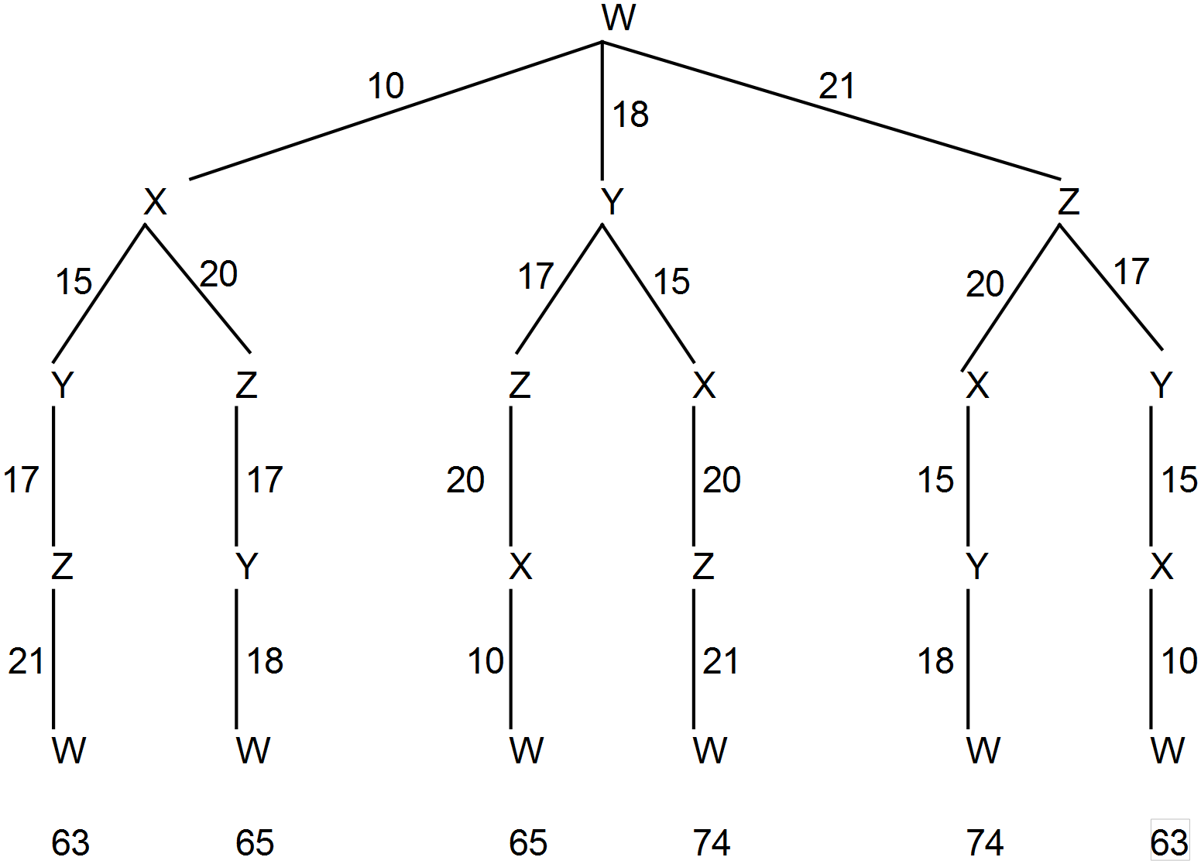

(a) How many different Hamiltonian circuits were available for the postal van? (1 mark)

(b) Identify the shortest Hamiltonian circuit and determine its length. (2 marks)

(c) What features will a path have if it is also a Hamiltonian circuit? (2 marks)

(d) Draw the weighted graph represented by the student’s tree diagram. (3 marks)

Solutions Question 4 Calc Free (8 marks)
Question 4(a)
6
Marking key/mathematical behaviours | Marks
- identifies Hamiltonian circuits | 1

Question 4 (b)
Marking key/mathematical behaviours | Marks
- identifies shortest circuit  - determines length of shortest circuit | 1  1

Question 4 (c)
It goes through each vertex only once
It starts and ends at the same vertex
Marking key/mathematical behaviours | Marks
- identifies cyclic nature  - describes path though vertices | 1  1

Question 4 (d)
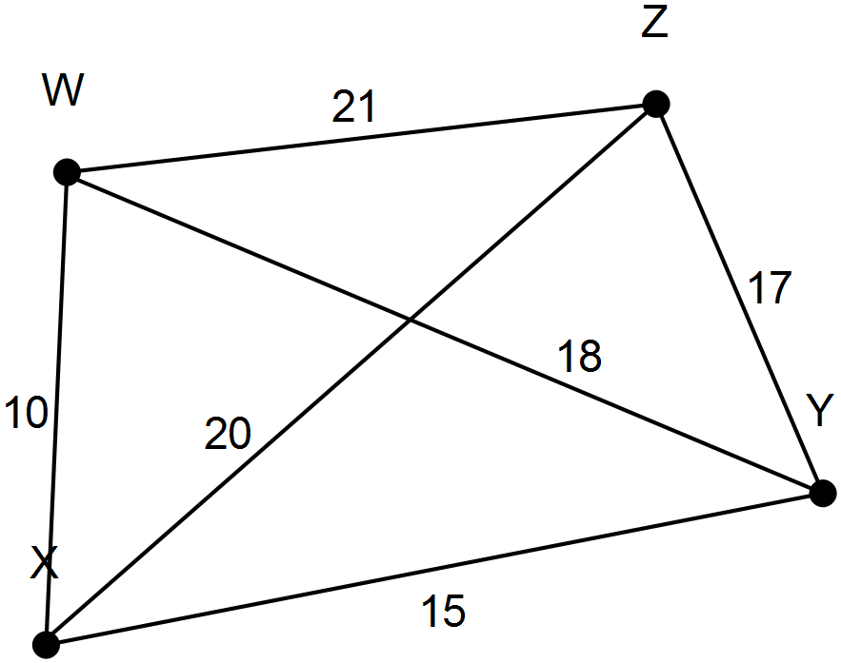Solution

Marking key/mathematical behaviours | Marks
- uses and labels correct number of nodes  - completes all edges  - places correct weights on all edges | 1  1  1

Question 5 Calc Free (9marks)

The numbers on the edges of the network below indicate the time (in minutes) that it takes to walk between the intersections of part of the central business district of an Australian city. Jake is currently at intersection E and he wishes to walk, in the shortest possible time, to meet a friend who is waiting for him at intersection B.

(a) State the route that Jake should follow to arrive at intersection B in the shortest possible time and also state the time it would take to travel that route. Show a method by which you determined your solution. (3 marks)
Jane also plans to walk from intersection E to intersection B. She too wants to arrive in the shortest possible time but she wants to go via the florist situated at intersection F.

(b) State the route Jane should take. (2 marks)
(c) Jane spent 5 minutes at the florist. How much longer did the journey take Jane than it took Jake?
(2marks)

(d) For the network drawn above, identify a Hamiltonian path. Give a practical example of how such a path of these roads might be used. (2 marks)

Solutions Question 5 Calc Free (9marks)

Question 5 (a)
EFGB (23), EFDGB (21), EACB (20)
Quickest route is E A C B. Time taken is 20 minutes.
Marking key/mathematical behaviours | Marks
- identifies edges for quickest route  - determines time taken  - shows a method for solution | 1  1  1
Question 5 (b)
Jane’s route: via F is E F D G B
Marking key/mathematical behaviours | Marks
- identifies initial edge and finishing point  - identifies edges for quickest route from F to B | 1  1
Question 5 (c)
Time taken via F = 21 minutes walking + 5 minutes at florist = 26 minutes.

26 mins – 20 mins = 6 minutes. Jane’s journey took 6 minutes longer.
Marking key/mathematical behaviours | Marks
- determines time taken via F  - determines difference in times | 1  1
Question 5 (d)
EFDGBCA Visiting every intersection to check traffic lights working.
Marking key/mathematical behaviours | Marks
- identifies Hamiltonian path  - identifies practical use of Hamiltonian path | 1  1

Question 6 Calc Free (13 marks)
The adjacency matrix shows the results of five students competing in a chess competition. Each student plays a game against each of the other students. A win is represented by 1 and a loss as 0. Each row represents the wins and losses for the player whose initial occurs at the beginning of the row. Each student is competing against the player whose initial is at the top of the column. The adjacency matrix (M) shows that Tom (T) beat Kate (K) and Andrew (A) but lost to Jane (J) and Liz (L).
T
M = K
J
A
L
(a) Explain the pattern of values on the leading diagonal of the adjacency matrix. (1 mark)
(b) Describe what the sum of each row represents. (2 marks)
(c) In the adjacency matrix, if the element in row m and column n is 0 then the element in row n and column m is 1. Explain the meaning of this statement. (2 marks)
(d) Use the vertices provided to construct the digraph represented by the adjacency matrix M. (3 marks)
J
K
T
A
L
The square of matrix M is given below.
T
M ² = K
J
A
L
(e) Tom beat two people who also beat Jane.
(i) Who were they? (1 mark)
(ii) Where is this represented in M ² ? (1 mark)
(f) What number occurs in column 5 of row 3? Describe what this number represents.
(2 marks)
(g) How many students beat only one other person who had also beaten Kate? (1 mark)
Solutions Question 6 Calc Free (13 marks)
Question 6 (a)
The values are all zero because players do not compete against themselves
Marking key/mathematical behaviours | Marks
- explains the values in the leading diagonal | 1
Question 6 (b)
Total number of games won by each player
Marking key/mathematical behaviours | Marks
- identifies total number of games  - describes games belonging to one player | 1  1
Question 6 (c)
The person in row m had lost to the person in column n
The person in row n must have beaten the person in column m. It is the same match so the opposite results are stored in the “complementary” positions..
Marking key/mathematical behaviours | Marks
- identifies the same match is described  - identifies opposite results for the opponents | 1  1
Question 6 (d)
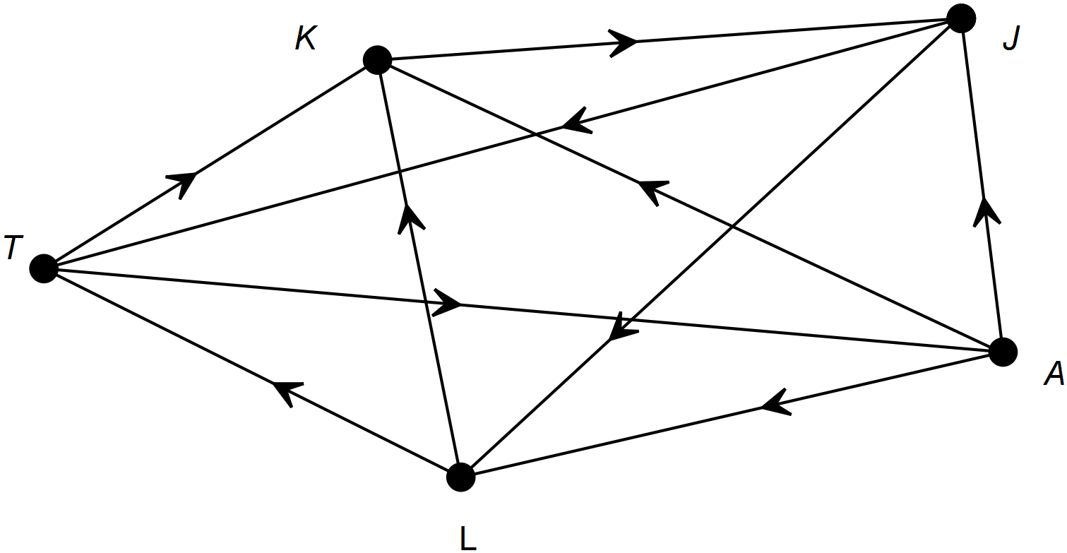

Marking key/mathematical behaviours | Marks
- draws a complete graph  - identifies 7 correct edges  - identifies remaining 2 correct edges | 1  1  1
Question 6 (e)
(i) Kate and Andrew
(ii) row 1 column 3
Marking key/mathematical behaviours | Marks
- interprets digraph  - relates digraph to matrix | 1  1
Question 6 (f)
0, There was no one that Jane beat who also beat Liz
Marking key/mathematical behaviours | Marks
- locates element in matrix  - interprets matrix | 1  1
Question 6 (g)
3
Marking key/mathematical behaviours | Marks
- uses adjacency matrix to solve problem | 1
Question 7 Calc Assumed (6 marks)
Adjacency matrix X shows the walks of length 1 for the following network.
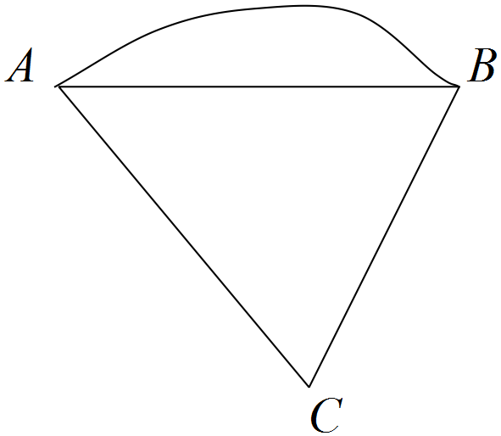

(a) Complete matrix X² (2 marks)
The first entry in matrix X² is 5.
(b) (i) State the meaning of the 5 in the context of the network. (1 mark)
(ii) Show one of the 5 walks clearly on the copy of the network given below. (1 mark)
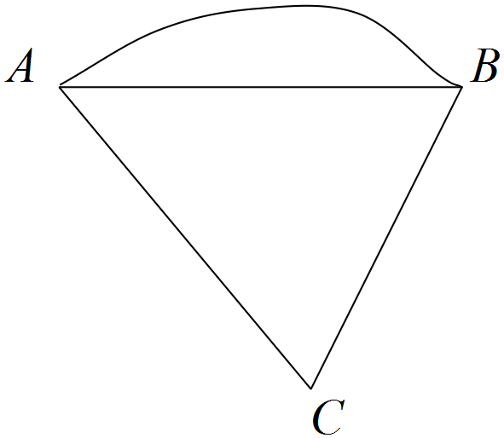

(c) If the path from A to C was one directional, state the new:
(i) matrix X. (1 mark)

(ii) matrix X². (1 mark)

Solutions Question 7 Calc Assumed (6 marks)
(a) 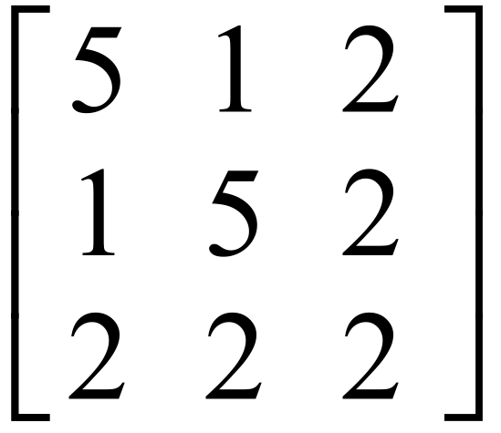
(b) (i) There are 5 ways of getting from A to A in 2 steps.
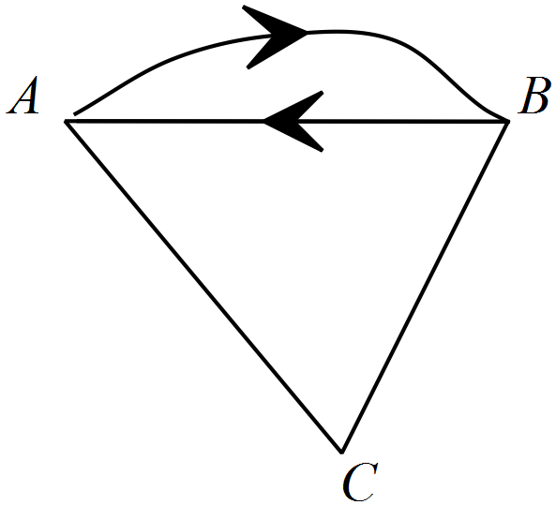 (ii)

(c) (i) X = 

(ii) X² = 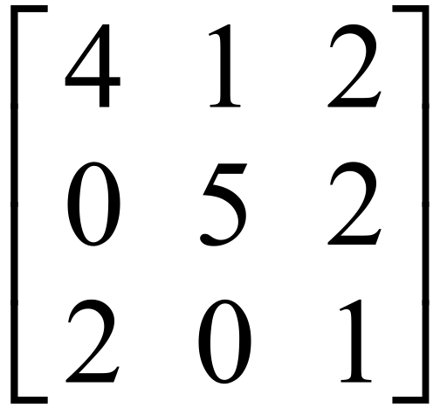 [6]

Question 8 Calc Free (7 marks)

Verify that the network below satisfies Euler’s Rule. (2 marks)

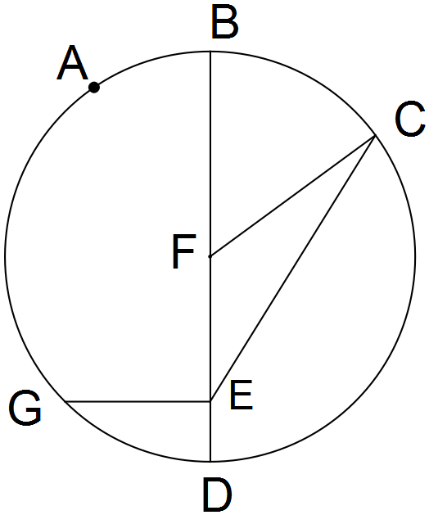

(b) Use the table to record whether each vertex is odd or even.

Vertex | A | B | C | D | E | F | G
Odd or Even
(2 marks)

Peter thinks that this network contains a semi-Eulerian trail.

(c) Give evidence to support or reject Peter’s claim. Include in your answer an
explanation of what a “semi-Eulerian “ trail is. (3 marks)

Solutions Question 8 Calc Free (7 marks)

(a) V = 7, F = 6, E = 11

∴ V + F – E = 2
(b)
Vertex | A | B | C | D | E | F | G
Odd or Even | Even | Odd | Even | Odd | Even | Odd | Odd

(c) A path which starts at an odd vertex, travels along every edge, once only, and finishes
at the other odd vertex. This network contains 4 odd vertices. Semi-Eulerian trails can
have only 2 odd vertices. So, Peter is not correct. [7]

Question 9 Calc Free (7 marks)

Any cube should satisfy Euler’s rule, V + F - E = 2

(a) Verify that it does. (2 marks)

A cube can be projected onto a plane to give a 2-D shape.

(b) Draw a planar graph in 2 dimensions which represents a cube. (2 marks)

The following network has 6 vertices. It is not planar.
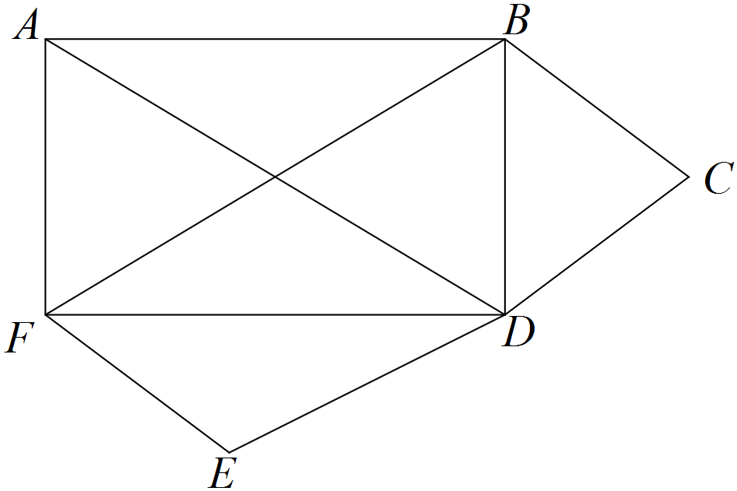

(c) How can you tell by looking that it is not planar? (1 mark)

(d) Redraw the network so that it is planar. (2 marks)

Solutions Question 9 Calc Free (7 marks)

(a) V = 8, F = 6, E = 12
8 + 6 – 12 = 2 Verified.
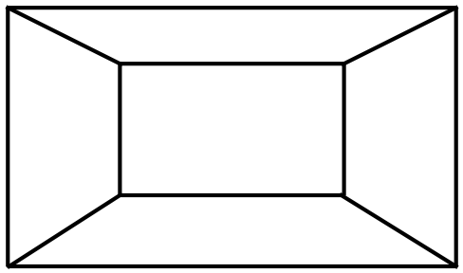 (b)

(c) Because BF crosses AD

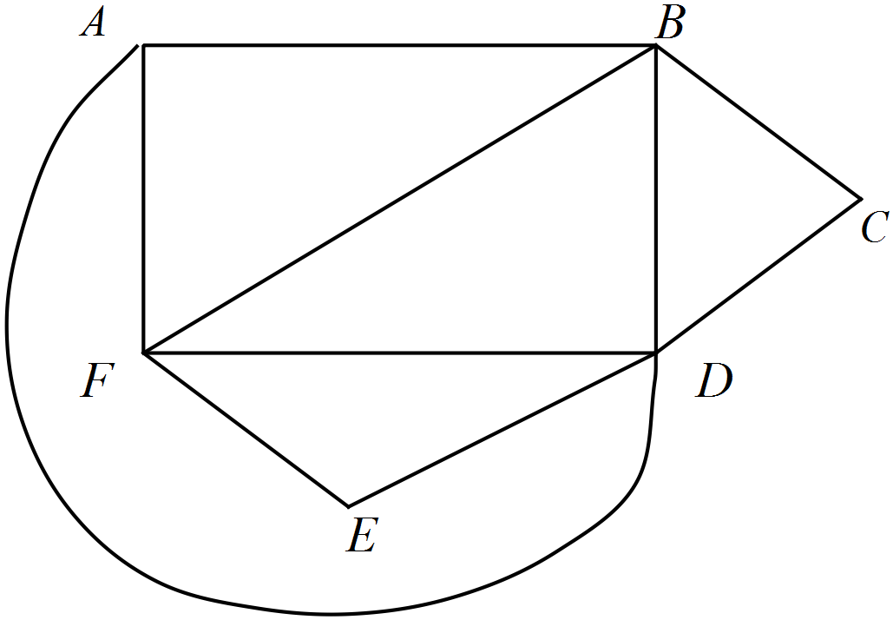(d) [7]

Question 10 Calc Free (7 marks)

Solutions Question 10 Calc Free (7 marks)

Question 11 Calc Free (6 marks)

Solutions Question 11 Calc Free (6 marks)

Question 12 Calc Free (7 marks)

Solutions Question 12 Calc Free (7 marks)

